

**HMICFRS Road Policing – Not Optional**

|  |  |
| --- | --- |
| **Required for:** | PCC Performance Meeting September 2020 |
| **Security Classification:** | **OFFICIAL** |
| **Handling information if required:** | N/A |
| **Suitable for publication:** | Yes |
| **Title:** | HMICFRS Road Policing – Not Optional |
| **Version:** | 1.0 |
| **Purpose:** | To provide an update to the PCC |
| **ACPO / Strategic Lead:** | ACC Dave Miller |
| **NDM / OSARA compliance:** | *Yes* |
| **Date created:** | 10/08/20 |
| **Date to be reviewed:** |  |

|  |  |
| --- | --- |
| **AUTHOR:** |  |
| **Name:** | Chief Inspector Michael Hodder/Supt Juliet Parker |
| **Job Title:** | Roads Policing Surrey & Sussex |
| **Telephone number:** | 07967988895 |
| **Email address:** | Michael.hodder@surrey.pnn.police.uk |

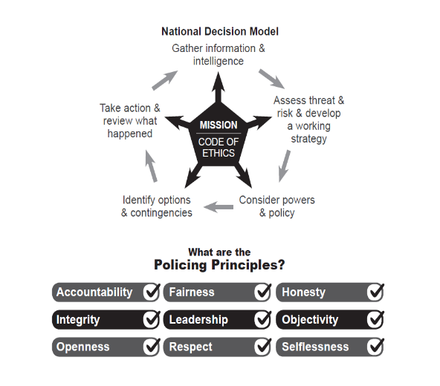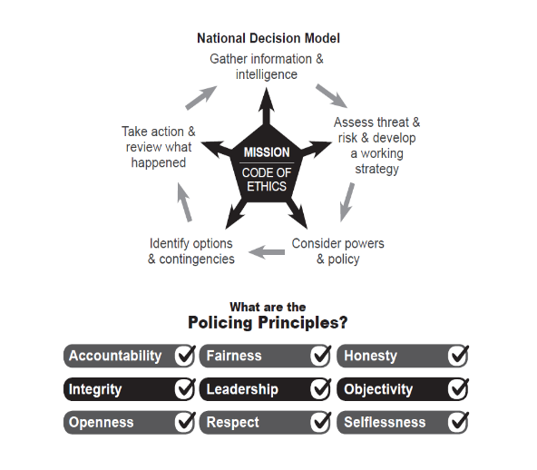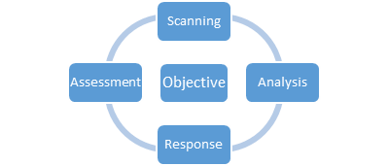

1. **Background**

Surrey Police Roads Policing Unit (RPU) is a collaborated unit with Sussex RPU via Op’s Command instigated many years ago (approximately 2012). The teams bring together joint working across both counties and alongside their TFU (Tactical Firearms Unit) colleagues across the two forces. This change of approach followed detailed consultation with both CC and OPCC.

The locally based but centrally managed teams are based at Burpham, and Godstone respectively. The teams consist of police officers with responsibility for the reduction in those killed or seriously injured on the roads across the county.

1. **RPU Objectives and Evaluation**

* Reduce death and serious injury
* Engage with motorists, cyclists, horse riders, power two wheelers, pedestrians
* Engage with partners to understand the data to enable forecasting (as best as possible) to ensure the right skills are deployed at the right time in the right area to maximise policing.
* The core for RPU is Engagement, Educations and Enforcement
* The ITAP (Intelligence, Tasking and Performance) alongside the Drive Smart, Surrey Safer Roads Partnership and the Traffic process Unit (TPU) monitor performance against enforcement and reduction year on year in relation o death and serious injury.

RPU are in a process of significant change following a change programme during which skills were not trained and officer numbers were reduced.

**3**. **Inspection by HMICFRS**

Overall, the review identified 13 recommendations where improvements can be made. The strength for RPU across Surrey & Sussex is the fact that RPU are now assessing demand based on Threat, Harm and Risk provided by ITAP.

Upon receipt of the report it was identified that Surrey Police has already begun to address the recommendations detailed within it as outlined in the Appendix A of this report.

1. **Future**

Aside from the above work on the recommendations, Surrey Police RPU are applying significant scrutiny to the report to consistently strive for excellence.

1. **Conclusion[s]**

* RPU is seeking investment and growth to enable a wider response to strategic and divisional roads.
* Surrey & Sussex RPU are already reviewing and responding to many of the recommendations.
* Surrey & Sussex have a good working relationship with their partnerships and the counties have a good joined up approach to problem solving.

1. **Attachments / Background Paper:**

Appendix A- Surrey Police response to the HMICFRS inspection of Roads Policing

**Appendix A:**

|  |  |
| --- | --- |
| Surrey Police response to the HMICFRS inspection of Roads Policing  July 2020 | SurreyCrest_Colour |

**1.0 Introduction**

The 2020 HMICFRS review of Roads Policing in England and Wales is welcomed by Ops Command as it provides an opportunity to highlight the work of the forces Roads Policing Unit’s (RPU) and the Partnership Team that is undertaken in an effort to reduce road death and serious injury to members of the public on our roads.

Although Surrey Police were not part of the inspection, the force was involved in the pre telephone inspection conversation thereby contributing to the report which has concluded in recommendations to Chief Constables nationally.

The recommendations from the report are recorded and monitored through our governance structures and the strategic lead ACC Miller.

**Chief Constable Briefing**

This report has been written in response to the release of the HMICFRS review following the joint Inspection of Roads Policing Review across England and Wales. The report contains national recommendations and areas of improvement (for action/consideration by all forces).

**National Recommendations**

There are 13 recommendations to the police and other bodies, which are intended to:

* Give clarity and guidance to the police and other bodies about their collective responsibilities;
* Improve forces’ understanding of the risks faced by road users in their areas;
* Make sure forces and road safety partners work together effectively;
* Bring about compliance with national guidance on the use of speed and red light cameras; and
* Provide greater support and training to officers who investigate road deaths.

Of the 13 there are 7 recommendations that are directed to Chief Constables across England and Wales and these are the ones that form the body of this report. The others are listed at the bottom for reference.

**Recommendation 4**

With immediate effect, chief constables should make sure that roads policing is included in their force’s strategic threat and risk assessments, which should identify the areas of highest harm and risk and the appropriate responses.

**Both Surrey & Sussex have recently included KSI reduction on their control strategy and this has been discussed at both force performance boards. There is still further work to be completed in respect of an overarching KSI reduction strategy and there is work being completed to write a Strategic Threat and Risk Assessment for roads policing in a similar way to the one that the forces have for armed policing.**

**There is already a tactical plan in existence that lays out what Ops Command are doing in relation to reducing harm on our roads. This now needs driving through the partnerships and internally with the divisions to make a real impact on road safety.**

**Recommendation 6**

With immediate effect, chief constables should make sure:

• their force has enough analytical capability (including that provided by road safety partnerships) to identify risks and threats on the road network within their force area;

• that information shared by partners relating to road safety is used effectively to reduce those risks and threats; and

• there is evaluation of road safety initiatives to establish their effectiveness.

**The partnerships between Surrey and Sussex share a data team that is based at Shoreham. This team provides data to each partnership to review risks and threats on the forces road networks. There is an analytical function within this. This is overlaid with data provided from other stakeholders within the partnerships to provide a rich picture of risk and threat within our roads system and reviewed at the tactical meetings within the partnership structure. Problem solving and resource is then allocated accordingly dependent on the issue identified.**

**The ultimate example for this is Annual Planning – the key priorities for the partnerships are always based on the most up to date data and analysis. Both partnerships review current data in the quarterly SRG meetings (the meeting cycle is based around this) so each organisation sitting around the table is alive to what is happening on the ground. Additionally, any issues that may arise outside of this (such as complaints from residents in a specific location) will be reviewed in line with the data for that specific issue highlighted and planning completed with this in mind.**

**Both forces are also part of Op Galileo. This project seeks to enhance the rich picture of partnership data and draw from greater sources to provide a more in-depth insight into vehicles and the behaviour of them enabling an enhanced response to threat and risk on the roads.**

**Currently there is little evaluation of the difference that road safety initiatives have on safety of road users. There is still more work required in this area which is the subject of national discussion in how this may be achieved. This is being led by ACC Barry and Surrey and Sussex feed into this piece of work.**

**Recommendation 8**

With immediate effect, chief constables should make sure that their force (or where applicable road safety partnerships of which their force is a member), comply with (the current version of) Department for Transport Circular 1/2007 in relation to the use of speed and red-light cameras.

**Both Surrey and Sussex comply with the DFT circular the main points of which are about site selection criteria for fixed sites, signing, visibility, appropriate speed limits, equipment operated in accordance with ACPO code of practice for RPET (Roads Policing Enforcement Technology) and collection of data.**

**However, the communications and publicity part is currently work in progress.  Sussex has a data portal which includes a map detailing all camera sites.  We are in the process of cleansing and refreshing this data.**

**In Surrey, we presently do not have a partnership website.  We are working on plans to have either a joint site with Sussex or an identical site to Sussex and this would then include all of the data and mapping.  However, as an interim solution there is a plan to look at mapping and data and make that available publicly.**

**Recommendation 9**

With immediate effect, in forces where Operation Snap (the provision of digital video footage by the public) has been adopted, chief constables should make sure that it has enough resources and process to support its efficient and effective use.

**Surrey currently utilise Single Online Home (SOH) which is managed by Criminal Justice and does not form part of Ops Command. SOH does not enable the public to submit footage and CJ have had to ensure a system is in place to work around this issue so that they can submit footage in a similar way to Op Snap.**

**In Sussex Crackdown is used which is a computer based system which offers far more than SOH and so the experience for both the public and the police back office function is easier and slicker than SOH.**

**Ops Command have a good relationship with CJ and consideration of utilising Crackdown in Surrey is being discussed.**

**Recommendation 10**

With immediate effect, chief constables should satisfy themselves that the resources allocated to policing the strategic road network within their force areas are sufficient. As part of that process they should make sure that their force has effective partnership arrangements including appropriate intelligence sharing agreements with relevant highways agencies.

**There is still work to do on relation to this recommendation. The number of RPU officers within Surrey was decreased in order to fund the uplift required to the Tactical Firearms Unit (TFU). Whilst TFU do assist with some RPU work it should be noted that the two team’s specialisms are different and so whilst they actively support each other with targeted casualty reduction patrols or operations it is RPU that provide the true specialism in this area and therefore have the most impression.**

**There is further demand work to be completed in respect of visibility and enforcement particularly on the motorway and strategic road network.**

**Ops Command has recently enhanced its intelligence function with the recruitment of an intelligence manager and Tasking and Co-ordinating Officers who produce briefings bespoke to the teams in relation to denying criminals the use of the roads. This has had very positive results with a lot of proactivity by the team and is measured through the commands performance meetings.**

**As previously mentioned the forces are part of Op Galileo and has set up a number of information sharing agreements in order to share key information and intelligence with partners to enhance the rich picture of vehicles and their behaviour. We also have data sharing agreements within the partnerships and actively share data with all partners.**

**Recommendation 11**

By 1 August 2021, the College of Policing should include a serious collision investigation module for completion along with the Professionalising Investigation Programme. This should include:

* • minimum national training standards; and
* • certification for all serious collision investigators.

Chief constables should make sure that all serious collision investigators in their force are then trained to those standards.

**The SCIU (Serious Collision Investigation Unit) is currently being reviewed by a newly appointed DI under the ownership of a DCI to ensure that the investigation standards are met. This is a massive step towards achieving this recommendation for 2021.**

**Recommendation 12**

With immediate effect, chief constables should make sure that appropriate welfare support is provided to specialist investigators and family liaison officers involved in the investigation of fatal road traffic collisions.

**Ops Command have a current Wellbeing Strategy one of the strands of which focusses on mental wellbeing.**

**The support for Serious Collision Investigation Unit (SCIU) officers is currently monitored through their line management via occupational health referrals and on-going support along with fast time defuse sessions if identified as necessary. The Family Liaison Officers (FLO) are not managed by RPU and come under the Major Crime Team (MCT) in Surrey and split between RPU and Crime in Sussex. FLO officers get the same pathway as described for the SCIU officers.  There is more to be done in supporting FLO and SCIU officers as well as increasing the number of FLO officers to ease the burden on their emotional welfare and this is included in the tactical plan for Wellbeing feeding into the wider Ops Command Strategy.**

**Other recommendations**

**Recommendation 1**

By 1 August 2021, the Department for Transport and the Home Office should develop and publish a national road safety strategy that provides clear guidance to the police, local authorities, highways agencies and other strategic partners. The strategy should include an explanation of the roles and responsibilities of each agency and the expectations of central government.

**Recommendation 2**

By 1 August 2021, the Home Office should revise the Strategic Policing Requirement to include an explicit reference to roads policing. Any revision should also include guidance on which bodies the requirement to collaborate with extends to.

**Recommendation 3**

By 1 April 2021, the Home Office should use the statutory power under section 7(4) of the Police Reform and Social Responsibility Act 2011 to issue guidance on what should be included within future police and crime plans. The guidance should require reference to roads policing in all police and crime plans.

**Recommendation 5**

By 1 April 2021, the National Police Chiefs’ Council should review the role and structure of national roads policing operations and intelligence.

**Recommendation 7**

By 1 August 2021, the Department for Transport, in consultation with the Home Office and the Welsh government should review and refresh Department for Transport Circular 1/2007. The Circular should include a requirement that forces, or local road safety partnerships should publish the annual revenue received as a result of the provision of driver offending-related training and how that revenue has been spent.

**Recommendation 13**

By 1 April 2021, the College of Policing and the National Police Chiefs’ Council should establish role profiles for defined functions within roads policing and identify the required skills and capabilities.

**Conclusion**

Aside from the above work on the recommendations, Surrey & Sussex Police are applying significant scrutiny to the HMICFRS report to consistently strive for excellence in managing all of the recommendations.

The inspection identified areas of improvement which are actively being addressed by Surrey Police as well as working with partners. Both forces are in a good position as a collaborated unit however it is important to highlight that Sussex have already instigated a large investment in RPU. Ops Command will be submitting a bid to Surrey Police to seek additional funding for an increase in resources within RPU within year 3 of the uplift investment. This will include details of how additional officers will contribute to reducing death and serious injuries on the road and how this can be measured to highlight the value they add.

There is scope for the CC’s of Surrey & Sussex to consider if Roads Policing should have a baseline on the Force’s STRA (Strategic Threat and Risk Assessment). At the moment this only relates to firearms and public order but by incorporating roads policing, it will allow enforcement, education and engagement on a consistent basis in order to police the county roads which include one of the largest sections of strategic roads (M25, M23, M3, A31, A331) in the country.