

**Body Worn Video Update**

|  |  |
| --- | --- |
| **Required for:** | *PCC Performance Meeting – September 2020* |
| **Security Classification** | **Official** |
| **Handling information if required:** |  |
| **Suitable for publication:** | *Yes* |
| **Title:** | Body Worn Video |
| **Version:** | 1.0 |
| **Purpose:** | Report on new BWV and efficiencies made |
| **ACPO / Strategic Lead:** | Joe Langford CDIO |
| **NDM / OSARA compliance:** | *Yes / No* |
| **Date created:** | 21.08.2020 |
| **Date to be reviewed:** |  |

|  |  |
| --- | --- |
| **AUTHOR:** |  |
| **Name:** | Scott Edwards |
| **Job Title:** | Strategic planning Officer |
| **Telephone number:** | Delivery Lead – Digital Division |
| **Email address:** | Scott.edwards@surrey.pnn.police.uk |

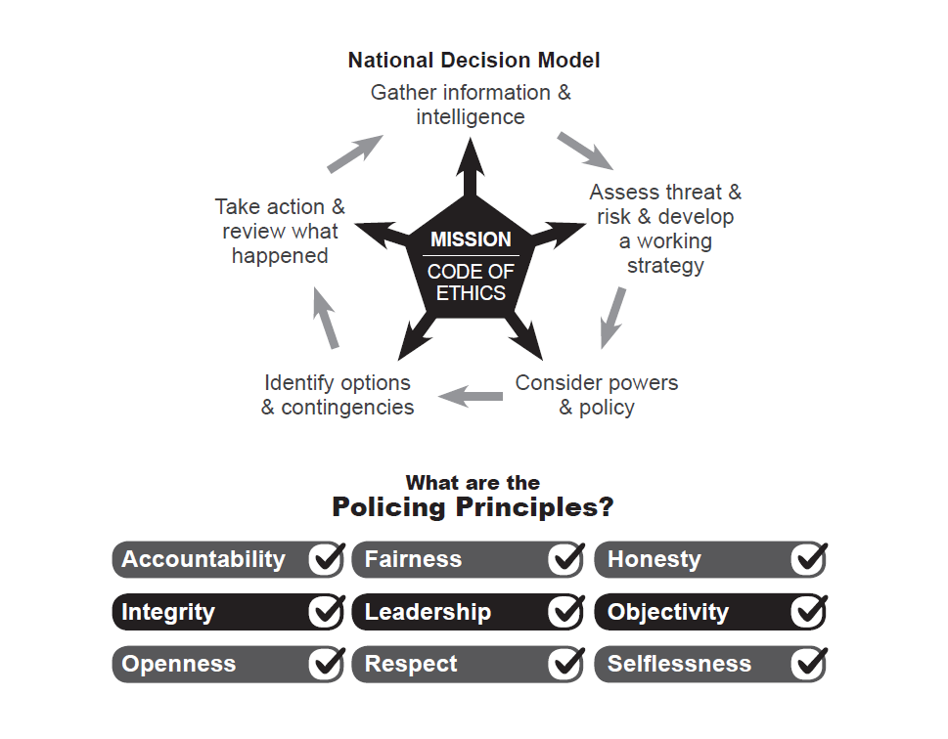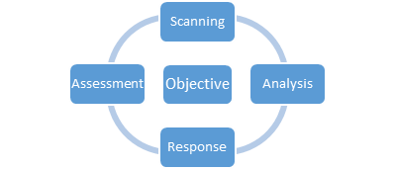

1. **Body Worn Video (BWV) Update**

The collaborated Body Worn Video replacement project is currently delivering to sites in both Surrey Police and Sussex Police. COVID-19 had an impact on the networking suppliers, meaning that progress was slowed; however, since going live in March 2020, we have progressed to deploying to 11 sites and, by the end of August, projected to have delivered to 19 sites in total (this is a combination of Surrey and Sussex locations):

|  |  |
| --- | --- |
| *Sussex* | *Surrey* |
| *Brighton John Street* | *Guildford* |
| *Hove* | *Reigate* |
| *Brighton Crowhurst Road* | *Salfords* |
| *Shoreham* | *Addlestone* |
| *Littlehampton* | *Epsom & Ewell* |
| *Worthing (Centenary House)* | *Farnham* |
| *Eastbourne (Hammonds Drive)* | *Staines* |
| *Lewes OPS Command (RPU)* | *Burpham (RPU)* |
| *Lewes OPS Command (TFU)* | *Woking* |
| *Kingstanding* |  |

The Digital Division Business Benefits Officer has been working with the refresh project from the business case stages and continues to report to the project board. At the time of writing (19.08.20), across both Forces, we have:

1. Recorded **30,481** pieces of footage. Of that number, the evidential data upload for Body Worn Video across the enlivened Surrey Police and Sussex Police sites is **6.2TB**.
2. This volume is composed of **8437** pieces of evidential footage which, under the old Body Worn Video platform, would have crudely equated to around double that amount of physical DVD burning. As a result:
   1. The Forces are seeing the risk of loss of the physical disks completely removed for these cases. This has allowed for a review of the Force Risk Register and for risks around potential fines as a result of lost data to be reviewed and partially downgraded. Fines from the Information Commissioners for lost data can vary – other Forces have been fined in excess £100,000 – so this should be seen as a significant shift. **Benefit BWV006 (1)**
   2. A financial saving (15p per disc ≈ £2531). **Benefit BWV001 (2)**
   3. Significantly, officer time spent burning DVDs (often unsuccessfully), and then their onward physical transportation, has been saved. Early investigative work by the Benefits Officer produced an assumption model that there would be a conservative average of **30 minutes** officer time per disc burn saved and this, therefore, is significant time saving per officer performing that function. **Benefit BWV006 (2)**
3. Having been considered as ‘relevant’ to an investigation or other policing activity, via a quick process, this footage will have been digitally transferred to the NICE Investigate platform for further investigation work quickly and seamlessly. Officers or staff no longer need to travel to the location where the footage resides to review it, nor wait for a physical DVD to arrive, as both the BWV VMS and the NICE Investigate platforms are now fully networked meaning desktop access from anywhere in the Surrey and Sussex estate is achievable.   
   **Benefit BWV004 (1); BWV005 (1); BWV008 (1)**
4. The digital transfer end-points with the right investigator significantly quicker than the previous platform; this means that review and onward transfer (via NICE Investigate) through to CPS (and onwards) is as efficient as can be envisaged at this time. No further data is currently available but anecdotal feedback from the frontline indicated that a (victim) non-supported Charge for ‘Attempted GBH’ file was sent for advice and the charging response from the CPS was received the same day. Both BWV and Nice investigate used to good effect.  
   **Benefit BWV005 (1).**
5. Where the new solution has been deployed, the old equipment has been removed from the frontline. Information from IT desktop engineers suggests that rebuilding the Reveal Media kiosks can take up to 5 person days to complete. The risk of failing cameras, and therefore the risk of evidential footage being lost, has been reduced. **Benefit BWV001 (1); BWV002 (1)**
6. Based on the initial survey results from Brighton Division, user satisfaction is high, staff are engaged with the product, and the pool deployment method does not appear to be an issue. Officer commentary is added below. Another user survey is in flight for Surrey. **Benefit BWV007 (1); BWV012 (1).**

**Officer feedback:**

* *“Not late off work waiting to burn BWV, can review footage instantly which aids with write ups, ensures footage is not accidently lost as it can easily be saved as evidential” – Brighton Division Officer*
* *“I no longer have to go to JSPS [John Street Police Station] to download footage and burning discs used to be a nightmare. The discs wouldn't always work and if someone else was using the system and I had travelled all the way there I would have to wait around. Also in time constraints, like someone being in custody it was difficult to get the evidence and then it would have to be taken to investigations. All causing a lot of travel.” – Brighton Division Officer*
* *“New body worn system is epic. Did a job in Brighton, docked it at John Street, viewed it on our phones within 5 minutes, attached it to [NICE] in seconds, absolute genius!” – Tactical Firearms Officer HQ*

The project is now planning implementation at further Sussex and Surrey sites as they become available as part of the connectivity refresh piece, with an anticipation that all planned sites will have been achieved by the end of 2020. Additional sites are also currently being reviewed, having been identified by organisational change and other growth factors.

The Digital Division Benefits Realisation Officer, having little in the way of baseline data from the old Reveal Media platform (the legacy system comparable in very few ways), continues to refine metrics to improve the visibility of the usage and benefits for the Motorola platform.

*Benefits definition:*

**BWV001:** Reduced use of IT infrastructure

**BWV002:** Reduction in support costs

**BWV004:** Improved data quality into Force systems – Timeliness

**BWV005**: Improved data quality within shared Force systems

**BWV006:** Improved data quality into Force systems – Security

**BWV007:** Better ways of deployment

**BVW008:** More Informed Officers: Increased use of existing force information/applications

**BVW012:** Part of wider change to working practices

1. **Decision[s] Required**

None, this paper is for information only.

1. **Attachments / Background Papers**

None.